Digital Literacy
Report

Name- Raman Malviya
Course code-CSE0001
Course Title- Digital Literacy
Reg no -25MIM10106
Date of submission- 31st march 2026

Introduction

This report documents my work on digital literacy. The project aims to build a comprehensive Digital Literacy Portfolio to help peers navigate professional online profiles, safe communication, and cyber awareness. It consists of 5 tasks ranging from visual design and professional networking to coding platforms and cybersecurity to the demonstration of core concepts of digital literacy.

Task 1 - Awareness Infographic
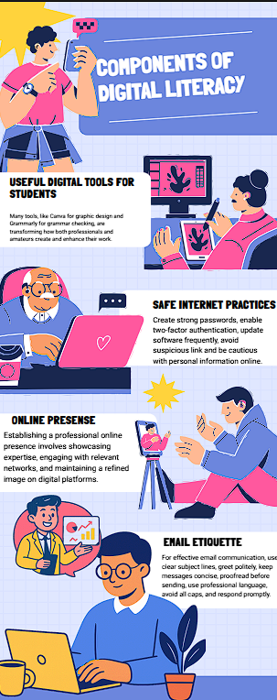
I created This one-page infographic using Canva. My design covers Four essential topics: Useful Digital Tools For students, Email Etiquette, and Professional Online Presence. We used clear visuals and concise text to make these concepts accessible to all .

Reflection: One thing I found interesting was how challenging it is to simplify complex security topics into short, punchy visual tips. I learned that "less is more" when designing for a student audience who might only glance at a poster for a few seconds.
Task 2 -Digital Portfolio

For this task, I set up and updated profiles on GitHub, LinkedIn, and stackoverflow. On GitHub, I created a specialized profile README detailing my branch and learning goals. On LinkedIn, I focused on my educational background and expected graduation year I even asked a programming question at which I had some doubt on stackoverflow and got a heads up for what to do.

Reflection: These platforms serve different purposes: GitHub is for my code, LinkedIn is for my professional network, and stack overflow for QnA . Over the next Five years, I plan to use these to document my projects and connect with industry mentors to prepare for internships.

Task 3- Explore Coding & Collaboration Platforms.
For the first part I used codechef to work on my python coding skills and solved a pretty basic problem head on it told me to create a simple asteric sign right triangle
And I did crack the code easily 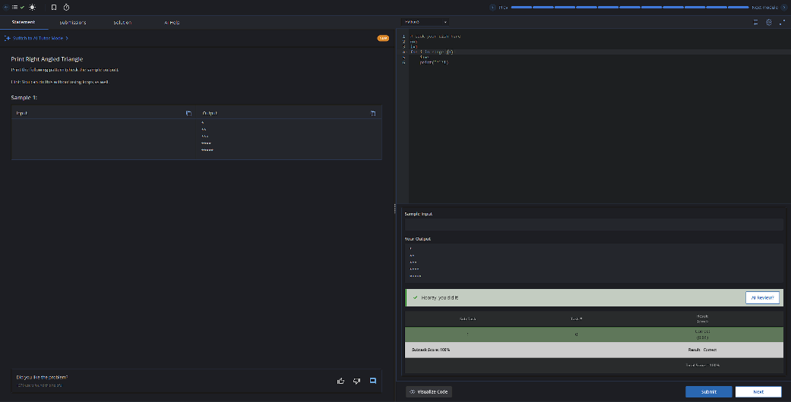
Google collaboration: we created a simple quiz on digital literacy using google forms it consisted of 5 questions which included mcq type and short answer type questions , bellow attached is the quiz and its response sheet
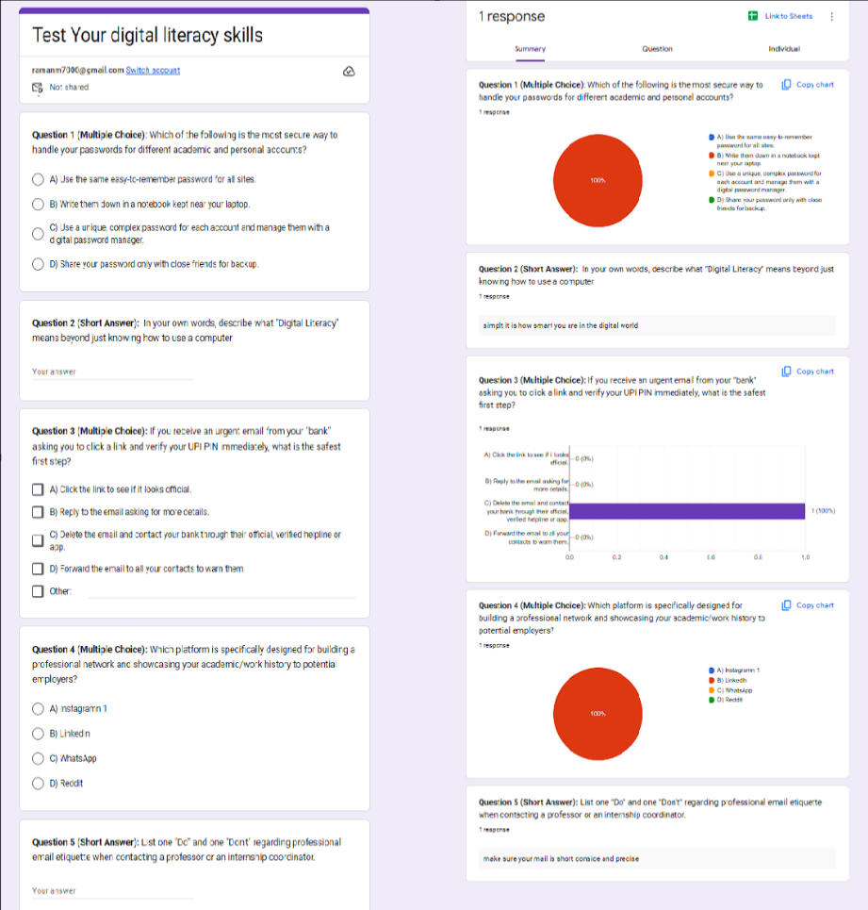
Task 4- Professional Email & Etiquette

I drafted two professional emails: one requesting an assignment extension and another inquiring about a summer internship. Both followed strict rules regarding subject lines, greetings, and professional tone which you can check in the email pdf.

Reflection: I once read about a student who missed a job opportunity because they used a casual words like “Hey” in an email to a recruiter. This taught me that digital communication is an extension of my professional brand. Using clear subject lines and respectful sign-offs ensures that the recipient takes my request seriously.

Task 5 - Cybercrime Awareness & Prevention
I researched The Digital arrest fraud which you can read in the Case study, focusing on how scammers trick victims by impersonating higher Authorities and using shame and their character as a factor for extortion of money from you.

Reflection: The "Digital Arrest" scam is a masterclass in psychological warfare. By weaponizing fear, social stigma, and forged authority, scammers bypass rational thought. It highlights that in an era of AI-driven deception, critical thinking and immediate reporting via 1930 or by visiting the NCCRP portal are our most vital tools for digital survival.
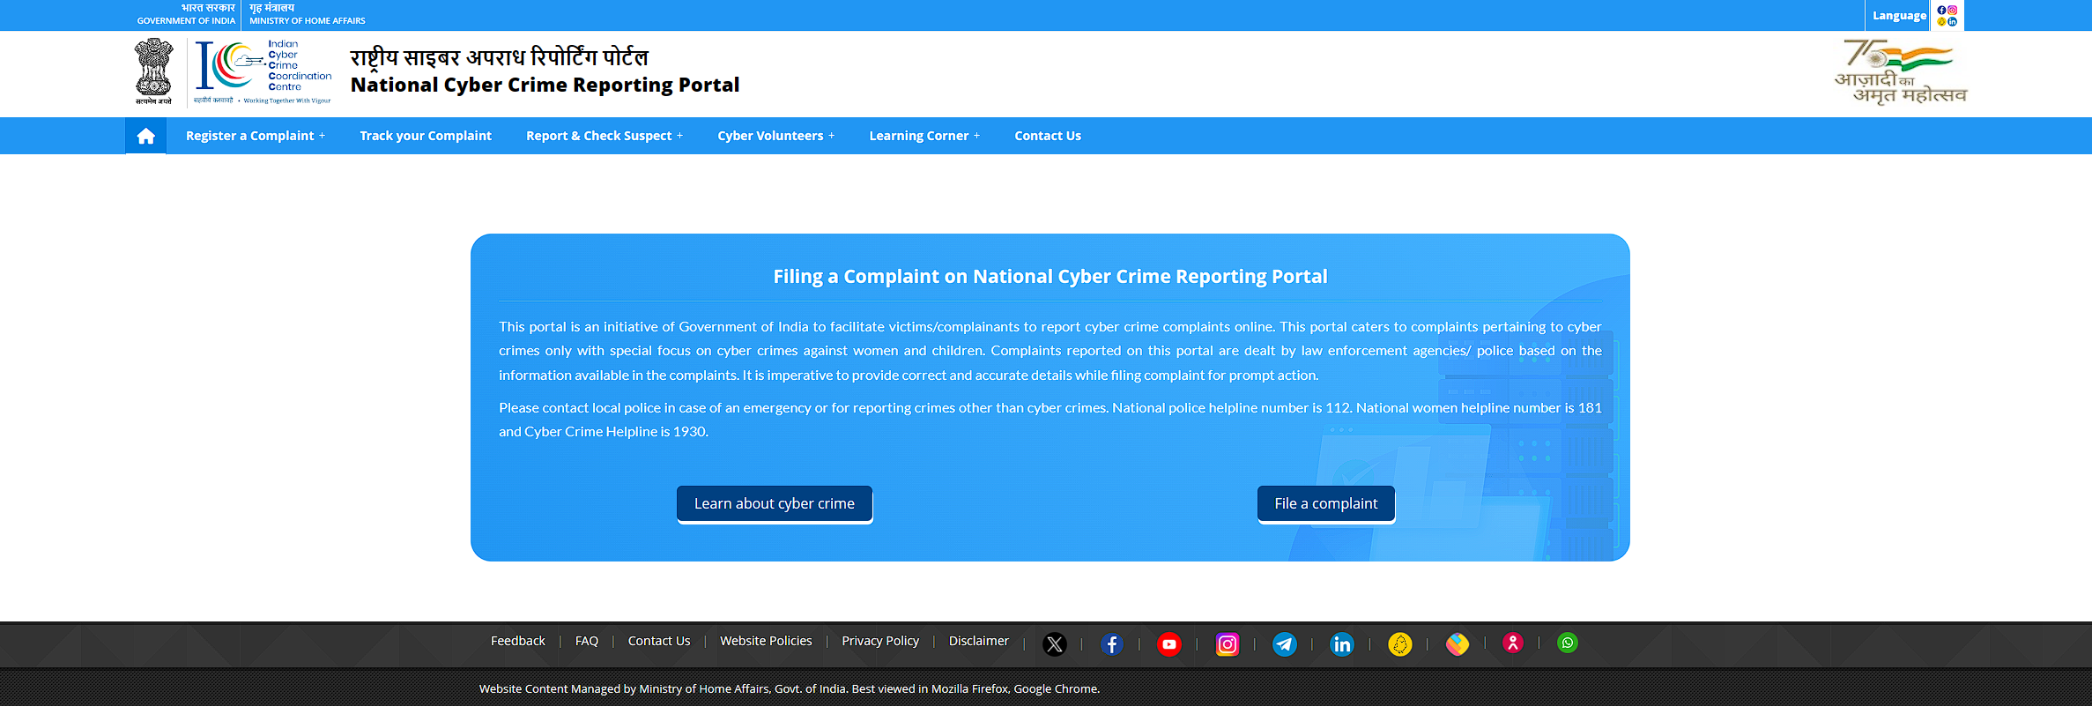

Conclusion

This project has equipped me with the foundational tools needed to be a responsible person online . I have learned that digital literacy is not just about using tools, but about communicating safely, professionally, and ethically in an interconnected world

References
- Canva: canva.com : For the inforgraphic
- GitHub: github.com : portfolio report
- LinkedIn: linkedin.com : portfolio report
- HackerRank: hackerrank.com : Coding problems
- National Cyber Crime Portal: cybercrime.gov.in : for online Consumer guidelines

